Akash Ravindran Intro to Web Development
NYU School of Engineering Spring 2016

Website: http://sites.bxmc.poly.edu/~akashravindran/Midterm/
Github Repo: https://github.com/ar3451/Web-Dev/tree/gh-pages

PROJECT PLAN:
Project Statement/Goal:
I wanted to create a website based around the Ace Attorney series, where anyone (whether they’re a fan of the series or even a beginner) could arrive at and use to explore and discover everything there is to know about the franchise. While there are fan wiki pages out there, they are limited when it comes to material. For example, most of those pages do not have walkthroughs of the games or even scripts (dialogue). I wanted to have everything and that’s what I had hoped to accomplish with this project.
Motivation/Drive/Purpose:
I’m a huge fan of the Ace Attorney series and I’ve always wanted to create a mystery genre game just like the franchise. When we were told to create a website about anything, I couldn’t think of any other franchise that I wanted to work with more than the Ace Attorney franchise. It was like killing two birds with one stone. I would be learning how to code properly whilst also learning more about the franchise that I love.
Target Audience:
My target audience ranges from strangers to the franchise to hardcore fans such as myself. I want my website to be used by people who need help getting through a game to a person who wants to know everything there is to know about the franchise. Obviously, if you aren’t a gamer or aren’t interested in the visual novel genre, then my website might not be for you.
Competitive Analysis:
I based my website around another game-related site- Serenesforest.net. Serenesforest.net is a website that has amassed everything there is to know about the Fire Emblem franchise (and still going). I wanted my site to be just as thorough but if we’re to look at websites related to the Ace Attorney franchise, a couple of sites come to mind. Aceattorney.wikia.com is also a website made by fans – for fans. It has in-depth information about characters and gives details about the games but it isn’t complete. Like I’ve stated above, the site doesn’t provide any means for a beginner to help himself complete the games (unless you count forums which are often too slow). There are plenty of fan-made, incomplete sites like Aceattorney.wikia.com but I want my site to be completed and thorough like serenesforest.net.
Content Inventory:
My site will have pictures, descriptions of the games, guides (or at least links to guides), trailers, news, and even links to purchase the games (through either Amazon or Nintendo).
Technical Requirements/Functionality:
To view the content on my site, you need the latest versions of Chrome, Internet Explorer, Firefox, or Safari. Otherwise, you may have trouble loading some of my features.
Creative Brief:
I will use a color scheme that is appropriate to each game. In other words, I will use important colors that signify something from the games.
Future Iterations:
I’m not sure how much I will be able to accomplish in the short span that we have but I would like to implement a search bar in the future. Also, I would like to create forums or chat rooms in which fans of the franchise can interact.
Risks:
Time is a huge factor. I’m taking 6 classes so I am constantly buried under work. Another factor is being able to properly utilize the things that I am taught. I tend to forget about useful or crucial facts that could help me when I’m in a pinch.

Sitemap:
As you can see, my website starts at the homepage. From there, you can either go to the Capcom site related to Phoenix Wright, or you can go to any one of the sites for the game. Regardless of where you start, you can cycle through the games from that page as they are connected and you can also return home at any time.
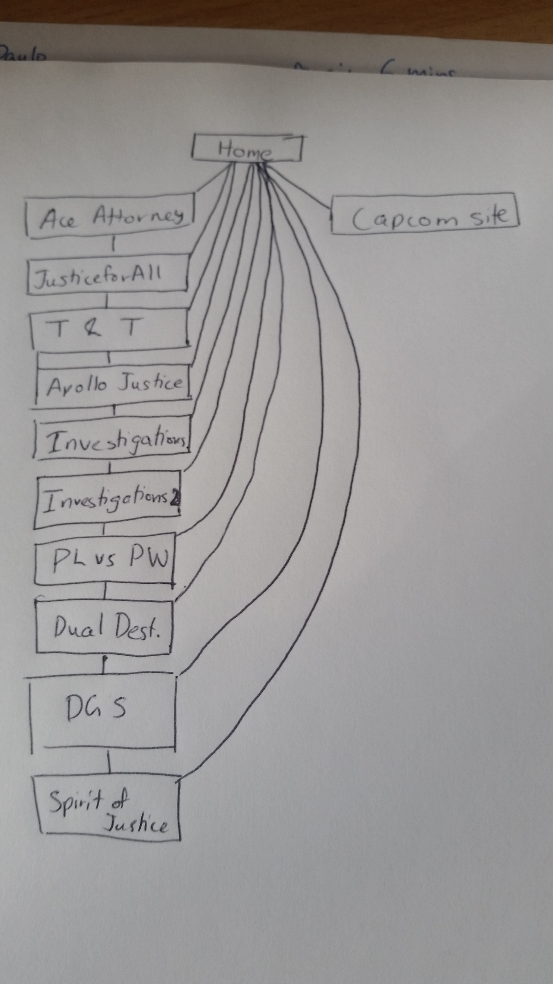

Wireframes:
This is the wireframe for my home page. It’ll have a logo in the corner, the title on top, descriptions in the middle, followed by pictures. Then I will list the games in the series and end off with an easter egg sort of deal.
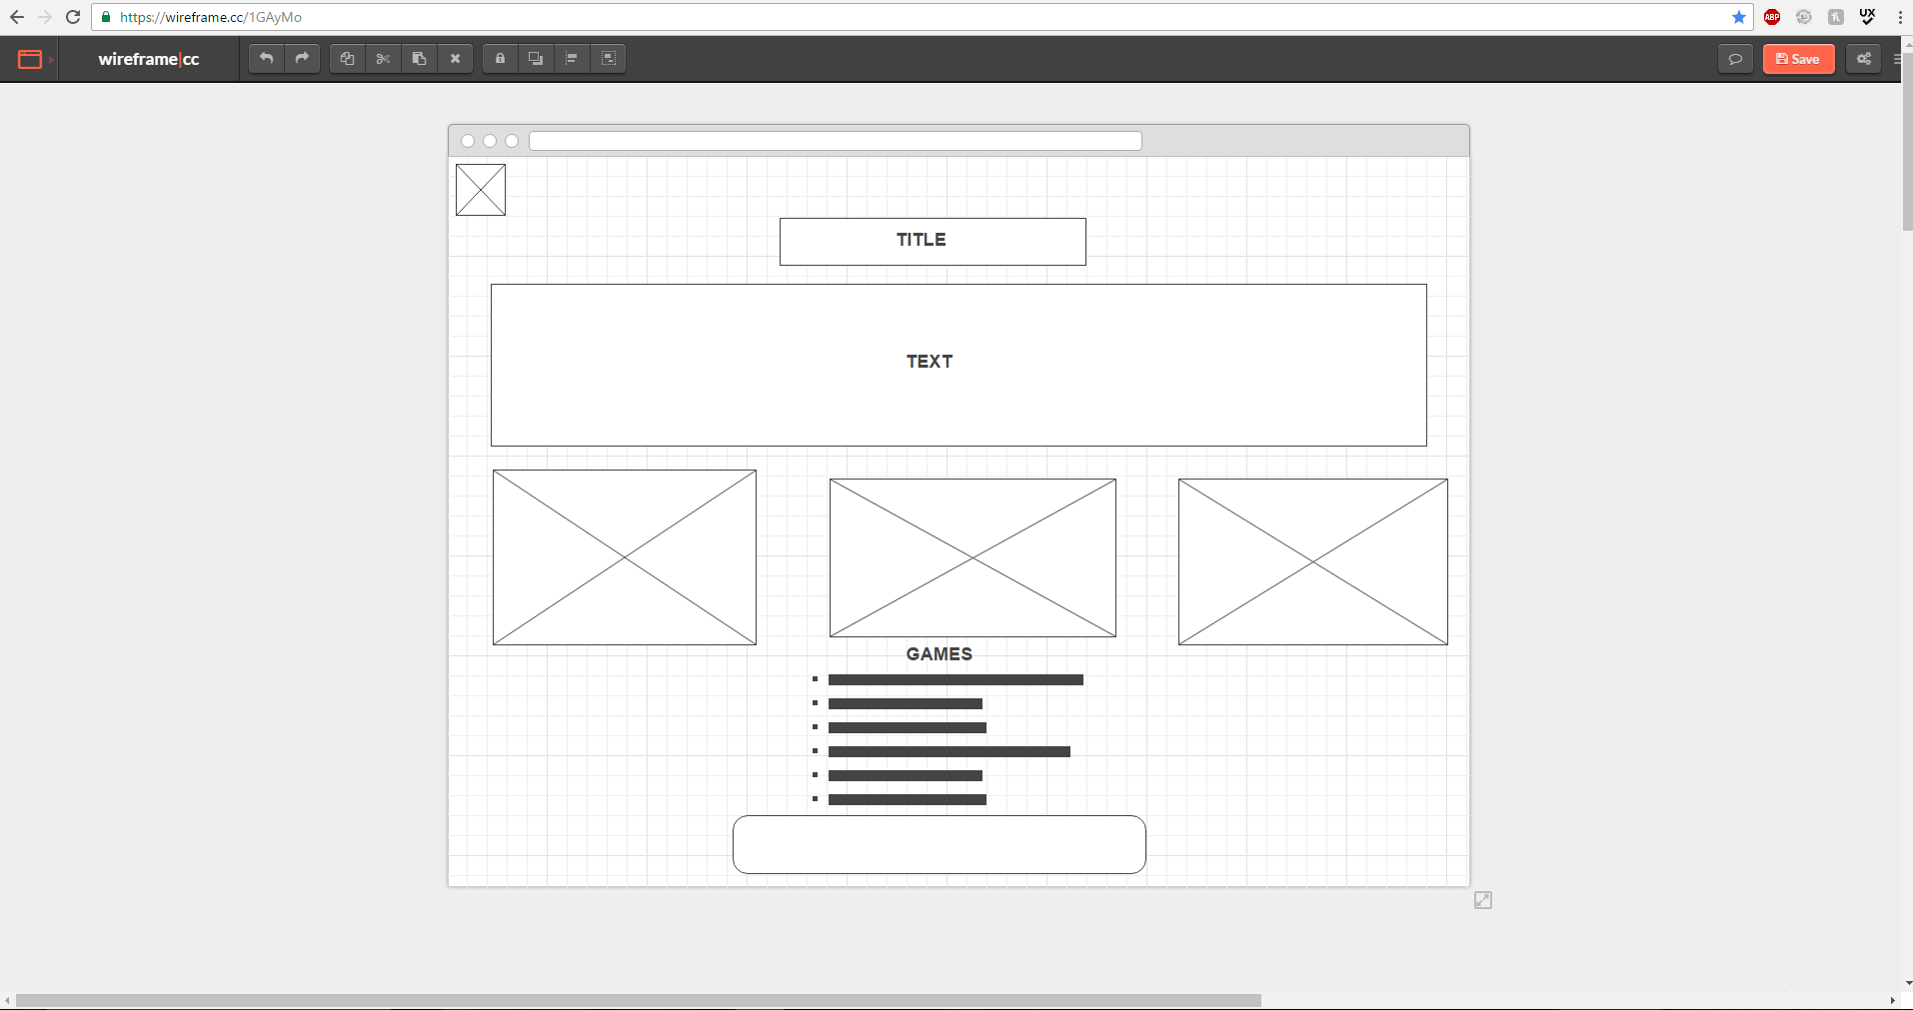
This is the wireframe for my game pages. They will all have the same format. It will consist of the logo in the top corner, the title in the middle, followed by a description. Then I will have a picture of the game which will also be a link, and it will be followed a video of the trailer. Finally, I’ll have a button that can take you back to the home screen.
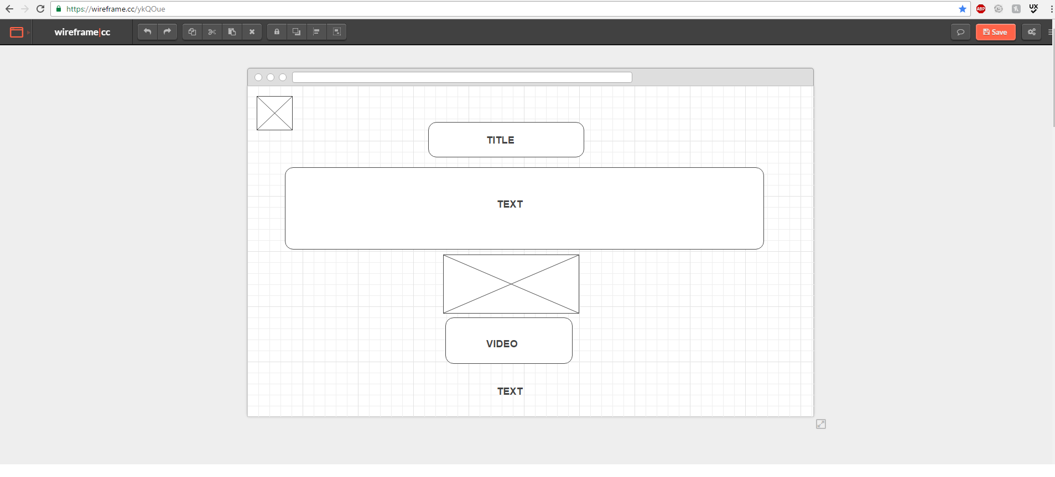
Style Guide:
These are the colors and fonts that I will use:
